IBM ASSIGNMENT – 2

Name: THARANI.K

College: MRK Institute Of Technology

ASSIGNMENT QUESTION: Build a python code, assume you get temperature and humidity values (generated with random function to a variable) and write a condition to continuously detect alarm in case of high temperature.

PYTHON CODE:

import random

import time

while(1!=0):

temperature = random.random()

humidity = random.random()

#round(temperature,2) #round(humidity,2)

("print Temperature: ","%.5f" % temperature) print("Humidity: ","%.5f" % humidity)

time.sleep(2)

if (temperature > 0.7):

print("high temperature")

if ( humidity >0.7):

print("high humidity")

print(“ “)

EXECUTION RESULTS:

Program:

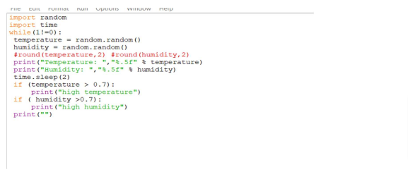

OUTPUT:

